11. A, 12. B, 17. D, 28. B 2017

21 C, 22.D, 25 C

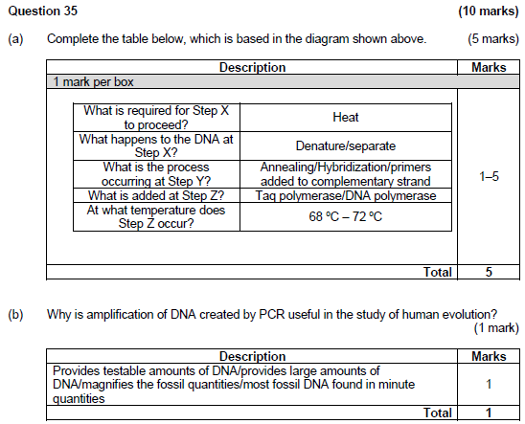

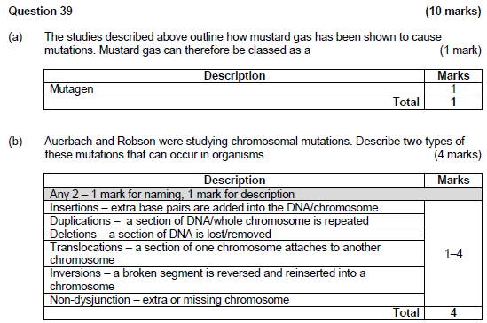

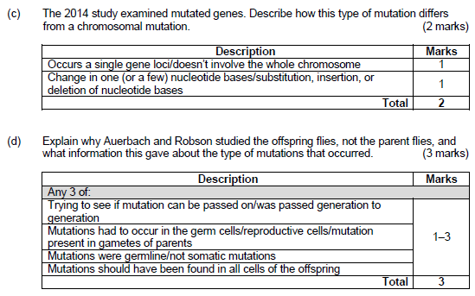

10. D, 3 B &D, 11 B, 16 D

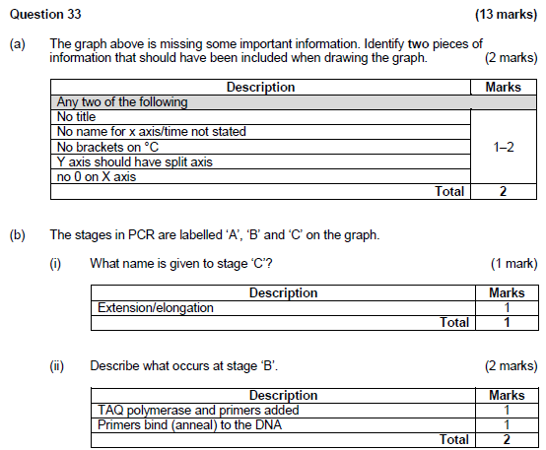

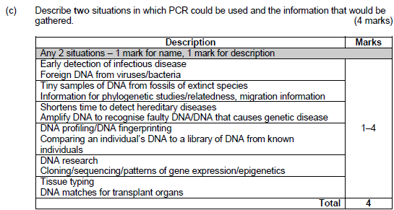

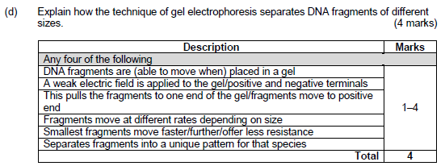

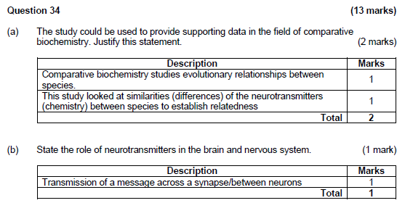

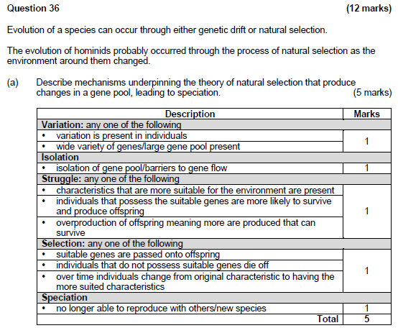

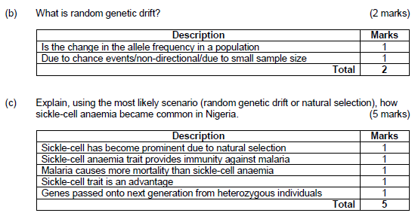

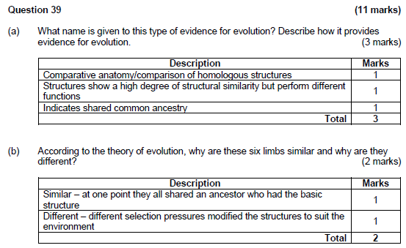

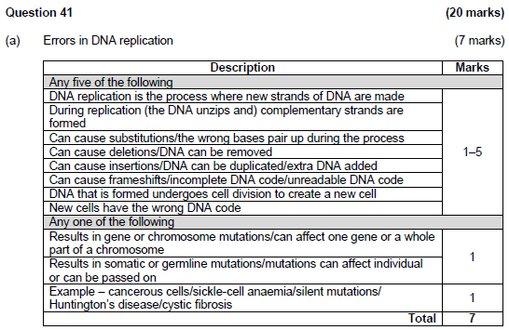

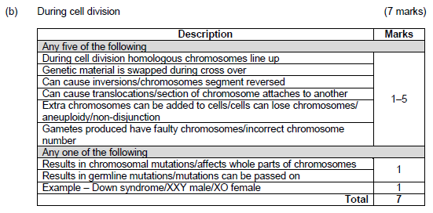

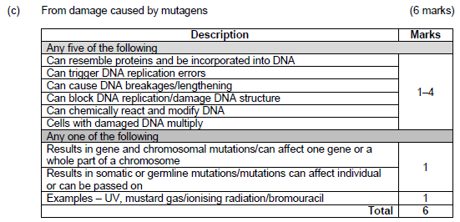

1. Distinguish between a gene mutation and a chromosomal mutation. [2]

* A gene mutation involves changes in a single gene so that the traits normally produced by the gene are changed or destroyed. [1]
* A chromosomal mutation involves changes in all or part of the chromosome and affect not just one but a number of genes. [1]

1. Explain why Tay-Sachs disease is considered a lethal recessive condition. [2]

* TS is a lethal recessive condition because the recessive allele for TS is not masked by a dominant normal allele. [1]
* The mutant allele is lethal as it brings about a missing enzyme resulting in the accumulation of a fatty substance in the nervous system, bring about an early death. [1]

1. Using examples, explain how a lethal recessive mutation such as the Tay-Sachs disease can bring about changes in the gene pool through the following two evolutionary mechanisms:
2. genetic drift [3]
3. natural selection [3]

Genetic Drift [3]

* TS disease has higher occurrence in Ashkenazi Jews in Eastern Europe [1]
* As a fatal disease, its frequency worldwide is very low but is higher amongst the A Jews because the Jewish population tends to be small and isolated. [1]
* This small and isolated population increases the chance of genetic drift – random, non-directional variation (which explains why a rare allele becomes more frequent in small populations) .[1]

Natural Selection [3]

* While individuals with two normal alleles would be more susceptible to TB, and would possibly die due to TB while individuals with two TS alleles would die early in life. [1]
* Heterozygotes, on the other hand, would have increased resistance to TB and therefore have a survival advantage and would pass their alleles on to the next generation. [1]
* Over time, the gene pool would have more Tay Sachs alleles /frequency of TS allele increases. [1]

|  |  |
| --- | --- |
| Polymerase Chain Reaction - named | 1 |
| Denaturation – double-stranded DNA is separated into single strands by heating to 96° C.  Annealing – use of Taq polymerase, primers, free nucleotides to complete DNA replication whilst cooled to 72°C.  Elongation– Process is repeated with newly formed DNA strands – thermos-cycling of heating and cooling to produce 2ⁿ copies for n cycles.  End result – Amplification of DNA | 4 |
| Gel Electrophoresis - named | 1 |
| DNA is cut by restriction enzymes to fragments of varying size (kilobases)  DNA is micro-pipetted into wells on a gel plate & subject to an electric current in a GE cell  Being negatively charged, DNA moved towards the positive electrode  Shorter, lighter DNA fragments travel faster than the longer, heavier DNA fragments.  A pattern of DNA bands can be detected when DNA treated with chemicals fluoresce under ultra violet light and photographed to show the DNA profile. | 5 |
| Ethical Issues (any 3 or suitable responses) | 3 |
| Genetic information is hereditary so knowledge of an individual’s own genome has implications for members of the family  Legislation is needed to ensure that there is no discrimination on the basis of genetic information  Genetic procedures as such are still costly – not accessible to all -, and there is no easy answer as to who should pay for them.  Our ability to interpret genomic information is still at an early stage. Even for those whom we know, with certainty, have a genetic condition, it can be challenging to identify a specific disease-causing gene change. We do carry many different types of genetic variants. So genomic testing can lead to incorrect or over-diagnosis.  Genomic information has the potential to influence the direction of human evolution because human intervention determines which embryos to implant and which to discard after identifying the genome. Sometimes the stem cells of healthy embryos are used as donor cells to generate tissue to treat individuals with genetic abnormalities.  When this occurs, the affected individual, who might otherwise die, may lead a relatively healthy life, even reaching reproductive age—then the defective alleles may be passed on to offspring and the genetic disorder is perpetuated.  Other issues surround the privacy and disclosure of genetic information and the storage or future use of test samples and data etc |  |